Y2Q4W3

Jesus Teaches

Make a list: Of the things that you need to live.
Ask: How do we get these things?

Say: Today we will find out what Jesus taught about getting the things you need.

Bible Story

Sing Songs

Return to tables
Memory Verse: Fill in the blanks and then say the memory verse on the colouring page.
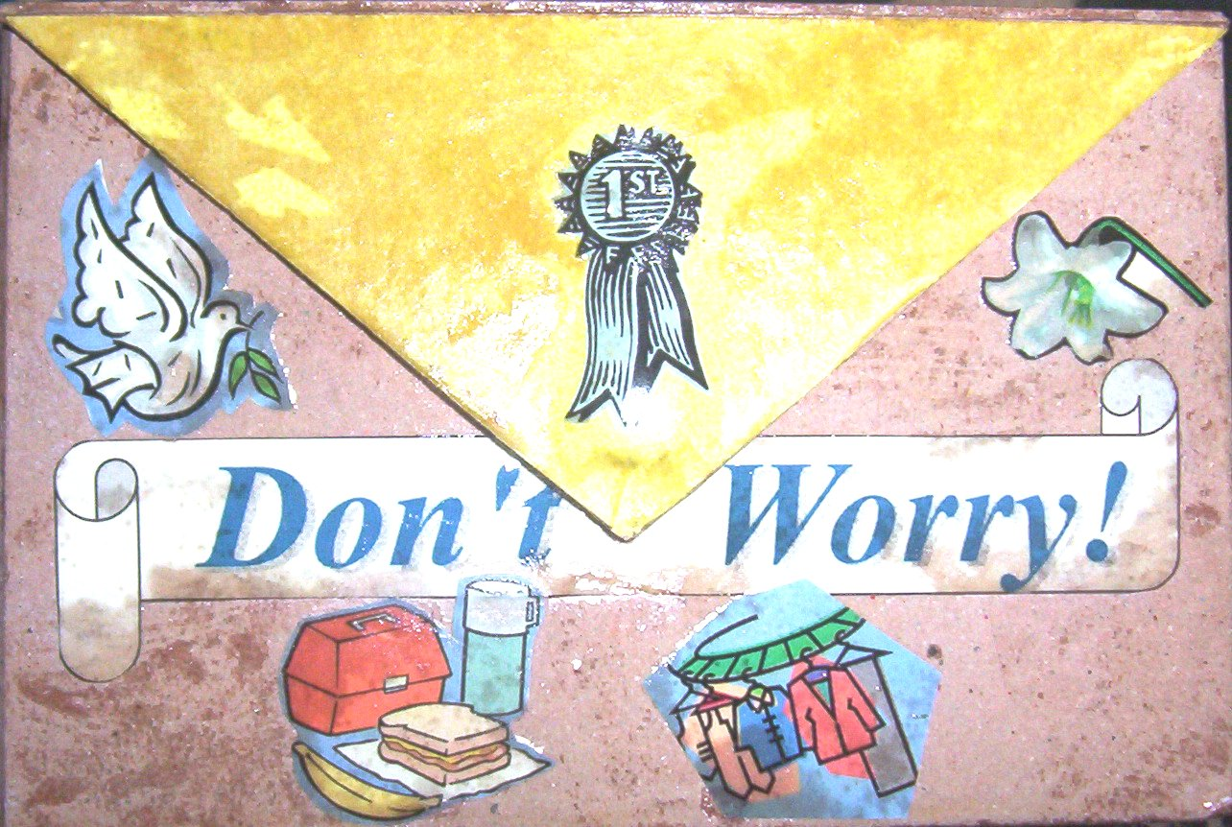
Craft: Front of box
- Add the "Don't Worry" banner
- Add the 1st prize, flower, dove, food and clothes.

Discuss the following depending on age, interest and time:
What is the difference between a need and a want?
What do we need to live?
How does God provide these things?
What things do we want? Are they good or bad, or neither good nor bad, things?
Why does Jesus compare Himself to a shepherd?
How do we get to heaven?
What does it mean to put God first?

Handout the prayer cards to be kept in the prayer boxes.

Revise: The list of things that we need to live and how God provides them.
Hand out: The "Don't Worry" stickers

Finish with prayer at each table. The children may say their prayers out loud for a small group or quietly for a large group, and then the teacher can finish.

